FUNDAMENTALS OF SOFTWARE ENGINEERING
ReadHub
Group members:
Kinza Saeed 24L-2527
Fajar Owaes 24L-2532
Hafiza Syeda Urwa 24L-2561

Deliverable #2
Submission date: 24nd March 2026
Project Introduction: (An online book shop (ReadHub))
The ReadHub is a web-based application designed to provide a modern, efficient, and user-friendly platform for book lovers to explore, purchase, rent, and download books online. With the rapid growth of digital technology, traditional bookstores often struggle to meet user demands due to limited inventory, lack of organization, and restricted accessibility. ReadHubaddresses these challenges by offering a centralized digital solution that enhances both user experience and administrative efficiency.
The system enables users to conveniently browse books by category, search by title, author, or genre, and access a wide range of physical books and eBooks from a single platform. It also introduces flexible options such as purchasing, renting eBooks, and requesting unavailable titles, ensuring that users have greater control and accessibility over their reading choices.
From an administrative perspective, ReadHub provides powerful tools to manage the entire system effectively. Administrators can handle user accounts, organize books into categories, maintain inventory, and update book details in real time. This automation reduces manual workload and ensures accurate and up-to-date records.

Sprint 1 — User Stories & Structured Specifications
Module: User & Admin Authentication | Project: READhub
User Stories
Story ID: US-01 Story Title: User Registration | Priority: High  Estimated Hours: 4
User Story:
As a new user, I want to create an account so that I can access the READhub platform.
Description:
This story covers the registration process for new users, including input of personal details, validation of fields, and confirmation of successful account creation.
Sub User Stories:
- As a new user, I want to fill in my name, email, and password so that my account can be created.
- As a new user, I want to receive a validation message if I enter an invalid email or weak password so that I can correct my input.
- As a new user, I want to see a confirmation message after successful registration so that I know my account has been created.
Acceptance Criteria:
- Registration form must include name, email, and password fields.
- System must validate email format and enforce a minimum password length.
- A success message must be shown after successful registration.
- Duplicate email registration must be rejected with an error message.

Story ID: US-02 Story Title: User Login | Priority: High  Estimated Hours: 3
User Story:
As a registered user, I want to log in to my account so that I can access my personalized features.
Description:
This story involves authenticating existing users by verifying their email and password credentials and granting them access to the platform upon success.
Sub User Stories:
- As a registered user, I want to enter my email and password to log in so that I can access the platform.
- As a registered user, I want to see an error message if I enter incorrect credentials so that I know my login failed.
- As a registered user, I want to be redirected to the home/dashboard page after a successful login.
- As a registered user, I want to click on “Forgot Password” so that I can reset my password if I forget it.
- As a registered user, I want to receive a password reset link via email so that I can create a new password.
- As a registered user, I want to set a new password securely so that I can log in again.
Acceptance Criteria:
- Login form must include email and password fields.
- System must display an error for incorrect credentials.
- User must be redirected to the dashboard upon successful login.
- Session must be maintained after login until the user logs out.
- A “Forgot Password” link must be available on the login page.
- User must be able to request a password reset using a registered email.
- System must send a secure, time-limited reset link to the user’s email.
- User must be able to set a new password using the reset link.

Story ID: US-03 Story Title: Admin Login | Priority: High  Estimated Hours: 3
User Story:
As an admin, I want to log in to a separate admin panel so that I can manage the platform.
Description:
This story covers the authentication of the admin user through a dedicated login interface that grants access to the admin dashboard for managing books and users.
Sub User Stories:
- As an admin, I want to enter my admin credentials so that I can access the admin dashboard.
- As an admin, I want to see an error message if my credentials are wrong so that I am aware of the failed attempt.
- As an admin, I want to be redirected to the admin dashboard upon successful login so that I can begin managing the system.
Acceptance Criteria:
- Admin login must be separate from user login.
- System must reject invalid admin credentials with an error message.
- Admin must be redirected to the admin dashboard after successful login.
- Admin role must be verified before granting access to management features.

Story ID: US-04 Story Title: User Logout | Priority: Medium  Estimated Hours: 2
User Story:
As a logged-in user or admin, I want to log out of my account so that my session is ended securely.
Description:
This story ensures that both users and admins can safely end their session by clicking a logout button, which clears their session and redirects them to the login page.
Sub User Stories:
- As a user, I want to click a logout button so that my session is terminated.
- As a user, I want to be redirected to the login page after logging out so that my account is secure.
Acceptance Criteria:
- A logout button must be visible in the navigation/header.
- Session must be cleared upon logout.
- User must be redirected to the login page after logging out.
- Accessing protected pages after logout must redirect back to login.

Story ID: US-05 Story Title: Database Setup for Users | Priority: High  Estimated Hours: 5
User Story:
As a developer, I want to set up the user database so that user information is stored and managed properly.
Description:
This story covers the technical setup of the user database schema, including defining table structure, fields, and ensuring passwords are stored securely using hashing.
Sub User Stories:
- As a developer, I want to create a users table with fields like ID, name, email, password, and role so that user data is structured.
- As a developer, I want to ensure passwords are stored securely (hashed) so that user data is protected.
Acceptance Criteria:
- Users table must include fields: ID, name, email, password (hashed), and role.
- Passwords must be hashed before being stored in the database.
- Database must enforce unique email constraint.
- Admin and user roles must be distinguishable in the database.

Story ID: US-06 Story Title: Inventory Management (Books/PDFs) | Priority: High  Estimated Hours: 5
User Story:
As an admin, I want to manage the inventory of books and PDFs so that users can access updated and organized reading material.
Description:
This story covers the functionality for managing the collection of books and PDFs in the system. It includes adding new content, updating existing records, and removing outdated materials to maintain an organized digital library.
Sub User Stories:
- As an admin, I want to add new books/PDFs so that users can access new content.
- As an admin, I want to edit book details so that incorrect or outdated information can be updated.
- As an admin, I want to delete books/PDFs so that irrelevant content is removed.
- As an admin, I want to view the list of available books so that I can manage inventory efficiently.
Acceptance Criteria:
- Admin must be able to add a new book with title, author, category, and file upload.
- System must validate all required fields before adding content.
- Admin must be able to update book details successfully.
- Admin must be able to delete books/PDFs from the system.
- Updated inventory must reflect immediately in the user view.
- As a developer, I want to ensure passwords are stored securely (hashed) so that user data is protected.

Structured Specifications
US-01.1: User fills in registration form
Type | Specification
Functional | The registration form must contain fields for name, email, and password.
Functional | All fields must be marked as required and must not be left empty on submission.
UX | Each field must display an inline error message if left blank or filled incorrectly.

US-01.2: Input validation on registration
Type | Specification
Functional | The system must validate that the email entered follows a correct email format (e.g., user@example.com).
Functional | The password must be at least 8 characters long and must be rejected if shorter.
UX | Validation errors must appear immediately below the relevant field without reloading the page.

US-01.3: Registration confirmation message
Type | Specification
Functional | The system must display a success message upon successful account creation.
Functional | Duplicate email addresses must be rejected with an appropriate error message.
UX | The confirmation message must be clearly visible and distinct from error messages.

US-02.1: User enters login credentials
Type | Specification
Functional | The login form must include email and password fields.
Functional | The system must verify the entered credentials against stored user records.
UX | The password field must mask the characters as they are typed.

US-02.2: Login error handling
Type | Specification
Functional | The system must display a clear error message if the email or password is incorrect.
Functional | The system must not specify which field is wrong to prevent credential enumeration.
Performance | The login response must be returned within 2 seconds of form submission.

US-02.3: Redirect after successful login
Type | Specification
Functional | Upon successful login, the user must be redirected to the home/dashboard page.
Functional | The session must be maintained after login and persist until the user logs out.
UX | The dashboard must load with the user's name visible in the navigation bar.
US-02.4: Forgot Password Link
Type | Specification
Functional | The login page must include a “Forgot Password” link.
UX | The link must be clearly visible below the login form.
US-02.5: Password Reset Request
Type | Specification
Functional | The system must allow users to enter their registered email.
Functional | A password reset link must be sent to the email if valid..
UX | A confirmation message must be displayed after request submission.
US-03.1: Admin enters login credentials
Type | Specification
Functional | The admin login page must be separate from the user login page.
Functional | The system must verify admin credentials against the admin records in the database.
UX | The admin login page must be clearly labeled to distinguish it from the user login.

US-03.2: Admin login error handling
Type | Specification
Functional | The system must reject invalid admin credentials and display an error message.
Functional | The admin role must be verified in the database before granting dashboard access.
Performance | Admin login response must be returned within 2 seconds of form submission.

US-03.3: Admin redirected to dashboard
Type | Specification
Functional | Upon successful login, the admin must be redirected to the admin dashboard.
Functional | Only users with admin role must be allowed to access admin panel routes.
UX | The admin dashboard must display an overview panel with management options upon login.

US-04.1: User clicks logout button
Type | Specification
Functional | A logout button must be visible and accessible from the navigation bar at all times.
Functional | Clicking the logout button must immediately terminate the current user session.
UX | The logout button must be clearly labeled and easy to locate in the interface.
US-04.2: Session cleared and redirect on logout
Type | Specification
Functional | All session data must be cleared from the server and browser upon logout.
Functional | The user must be redirected to the login page immediately after logout.
Performance | Logout must complete and redirect within 1 second of clicking the button.

US-05.1: Create Users Table
Type | Specification
Functional | The database must include a `users` table with fields: ID (primary key), name, email, password, and role.
Functional | The `email` field must be unique to prevent duplicate registrations.
UX | Error messages must be returned if a duplicate email is attempted during registration.

US-05.2: Secure Password Storage
Type | Specification
Functional | Passwords must be hashed before being stored in the database.
Functional | The hashing algorithm must follow industry standards (e.g., bcrypt, Argon2).
Performance | Password hashing must complete within 1 second to avoid delays in registration/login.

US-05.3: Role Management
Type | Specification
Functional | The `role` field must distinguish between `user` and `admin`.
Functional | Role-based access control must be enforced at the application level.
UX | Admin users must have access to management features, while regular users must be restricted.

US-05.4: Data Integrity & Constraints
Type | Specification
Functional | All fields (name, email, password, role) must be required when creating a new user record.
Functional | Database must enforce referential integrity for related tables (e.g., linking users to activity logs).
Performance | Queries on the `users` table must return results within 2 seconds under normal load.

US-06.1: Add new book/PDF
Type | Specification
Functional | The system must provide a form to add book title, author, category, and upload file.
Functional | All fields must be required before submission.
UX | A success message must be displayed after adding a book.
US-06.2: Edit book details
Type | Specification
Functional | The admin must be able to update book information..
Functional | Changes must be saved in the database immediately.
UX | Updated data must reflect without page reload (if possible).

US-06.3: Delete book/PDF
Type | Specification
Functional | The admin must be able to delete a selected book.
Functional | A confirmation prompt must appear before deletion.
UX | The book must be removed from the list instantly after deletion.

US-06.4: View inventory list
Type | Specification
Functional | The system must display all available books in a list format..
Functional | Books must include title, author, and category.
UX | The list should be searchable and easy to navigate.

Trello Screenshots:
Scrum Board: sprint1 Initial State
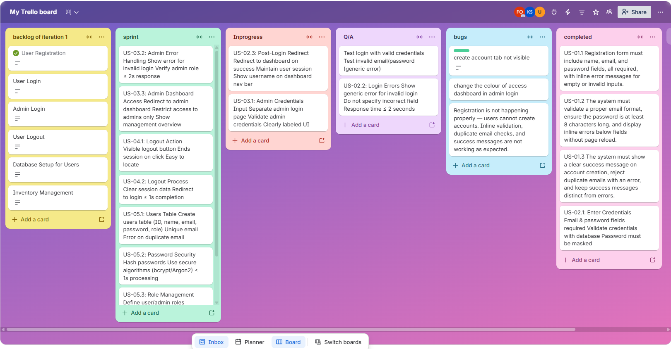

Scrum Board: sprint1 Mid State
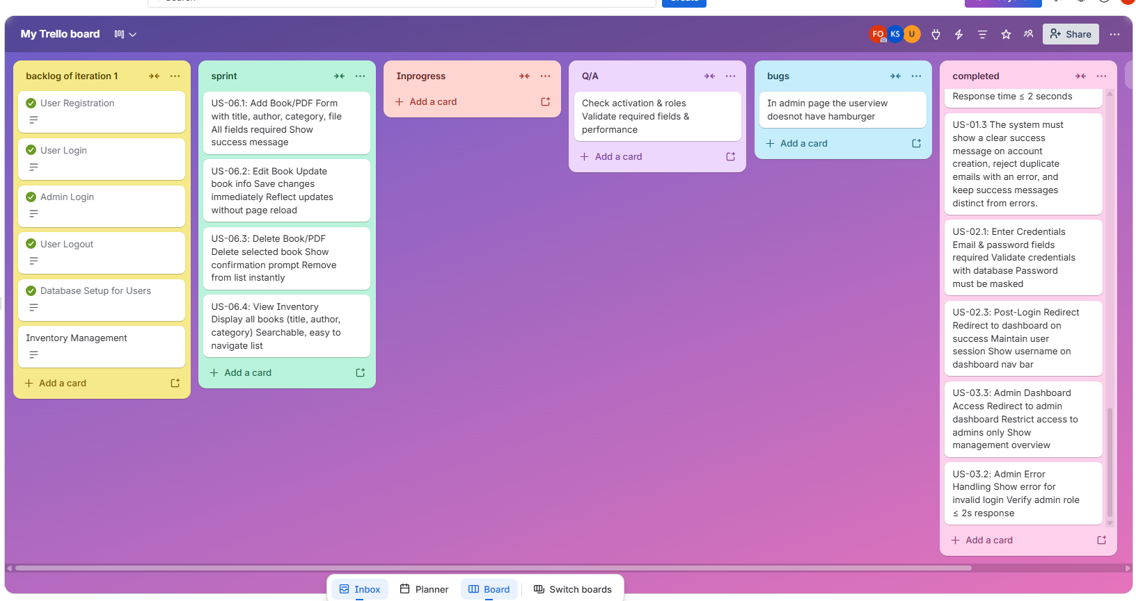

Scrum Board: sprint1 Final State
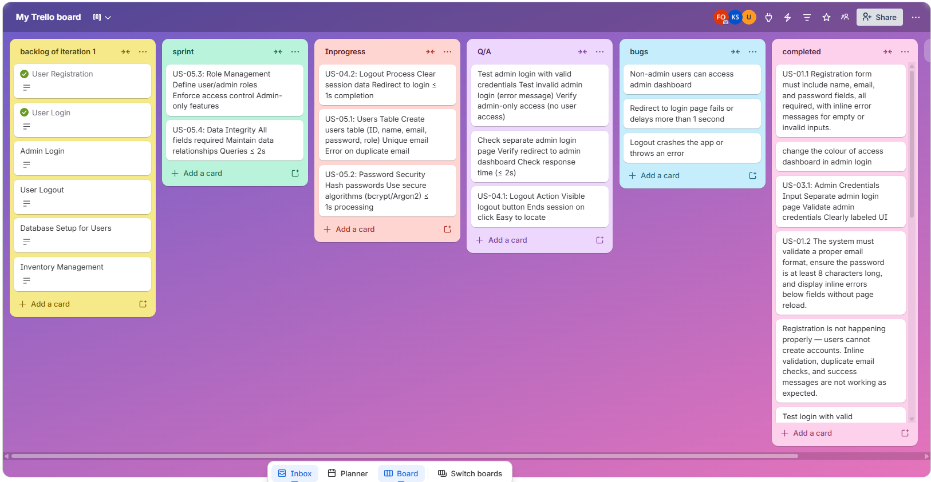

The Inventory Management feature was planned for Sprint 1 but could not be completed within the sprint timeframe so It has therefore been moved to Sprint 2 for full implementation and testing.

Burn-down chart for iteration1:

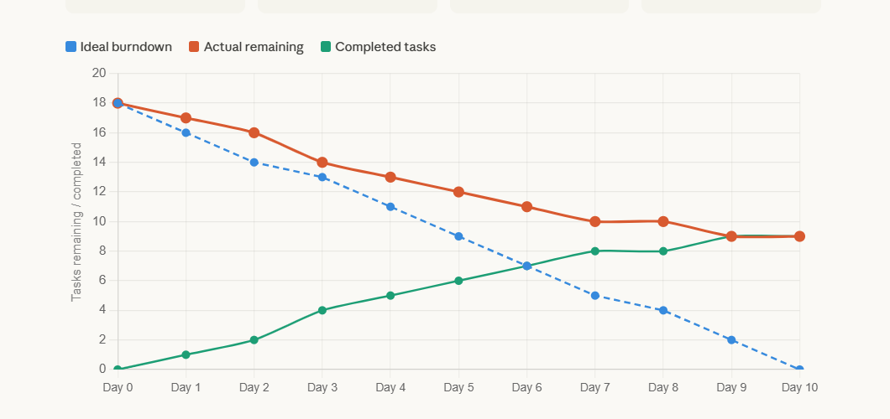

NFR Specification
1. Performance
The system must return a response for user registration and login within 2 seconds of form submission under normal load conditions. Admin login must also respond within 2 seconds. The logout process must complete and redirect the user to the login page within 1 second of clicking the logout button. Password hashing during registration and login must complete within 1 second to avoid noticeable delays. Database queries on the users table must return results within 2 seconds under normal operating conditions.
2. Security
All user passwords must be hashed before being stored in the database using an industry-standard hashing algorithm such as bcrypt or Argon2. Plain-text passwords must never be stored or transmitted. The system must enforce role-based access control, ensuring that only users with an admin role can access admin panel routes and management features. Regular users must be restricted from accessing any admin functionality. Session data must be fully cleared from both the server and the browser upon logout, preventing unauthorized access to protected pages after a session ends.
3. Usability (UX)
All forms, including registration, user login, and admin login, must display inline error messages directly below the relevant fields without requiring a page reload. Error messages must be clearly distinguishable from success messages to avoid user confusion. The admin login page must be clearly labeled to differentiate it from the regular user login page. The logout button must be visible and accessible from the navigation bar at all times and must be easy to locate. After successfully adding a book, a clear success message must be displayed to confirm the action to the admin.
4. Reliability
The system must prevent duplicate user accounts by enforcing a unique constraint on the email field at the database level. If a duplicate email is submitted during registration, an appropriate error message must be returned to the user. All required fields in the users table — including name, email, password, and role — must be enforced at the database level to maintain data integrity. The system must also maintain referential integrity between related tables, such as linking users to activity logs.
5. Maintainability
The database schema must be structured with clearly defined fields and constraints so that future developers can extend or modify it without breaking existing functionality. Role distinctions between user and admin must be handled consistently at both the database and application levels to ensure that access control logic remains easy to update and audit.
6. Availability
The inventory list must reflect any additions, updates, or deletions made by the admin immediately, ensuring that users always see the most current version of available books and PDFs without needing to refresh the page manually.
Iteration 1 implementation screen shots:
Login page:
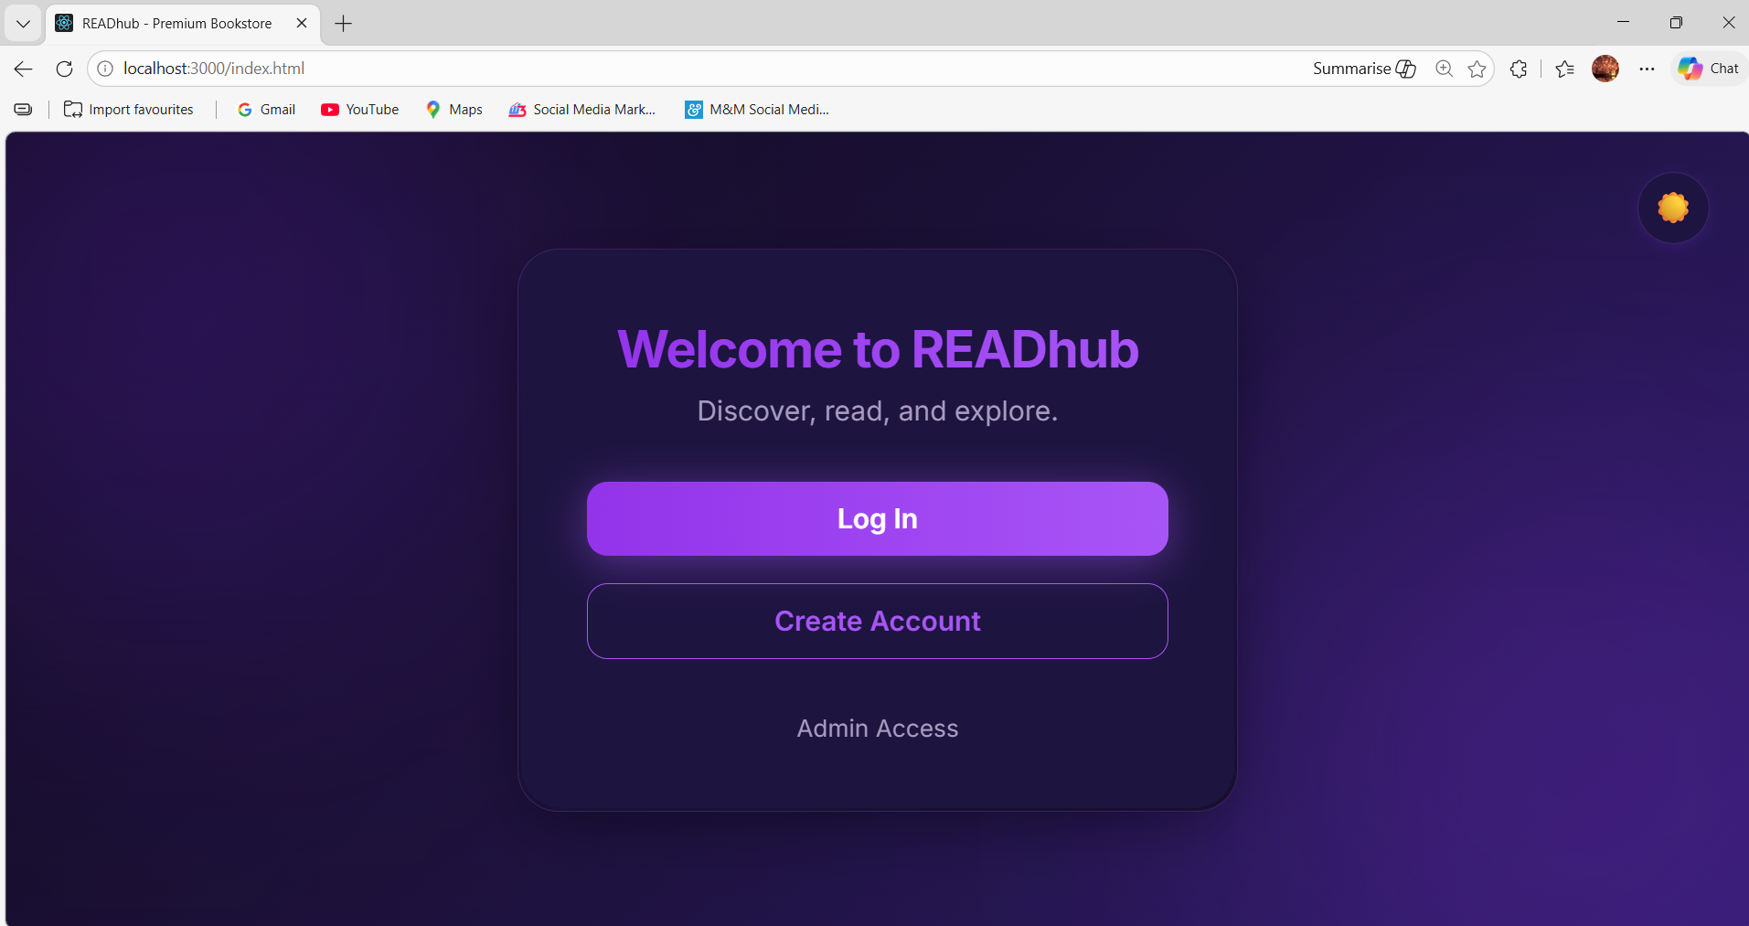
login page with 2 modes dark and night
Sign up for user:
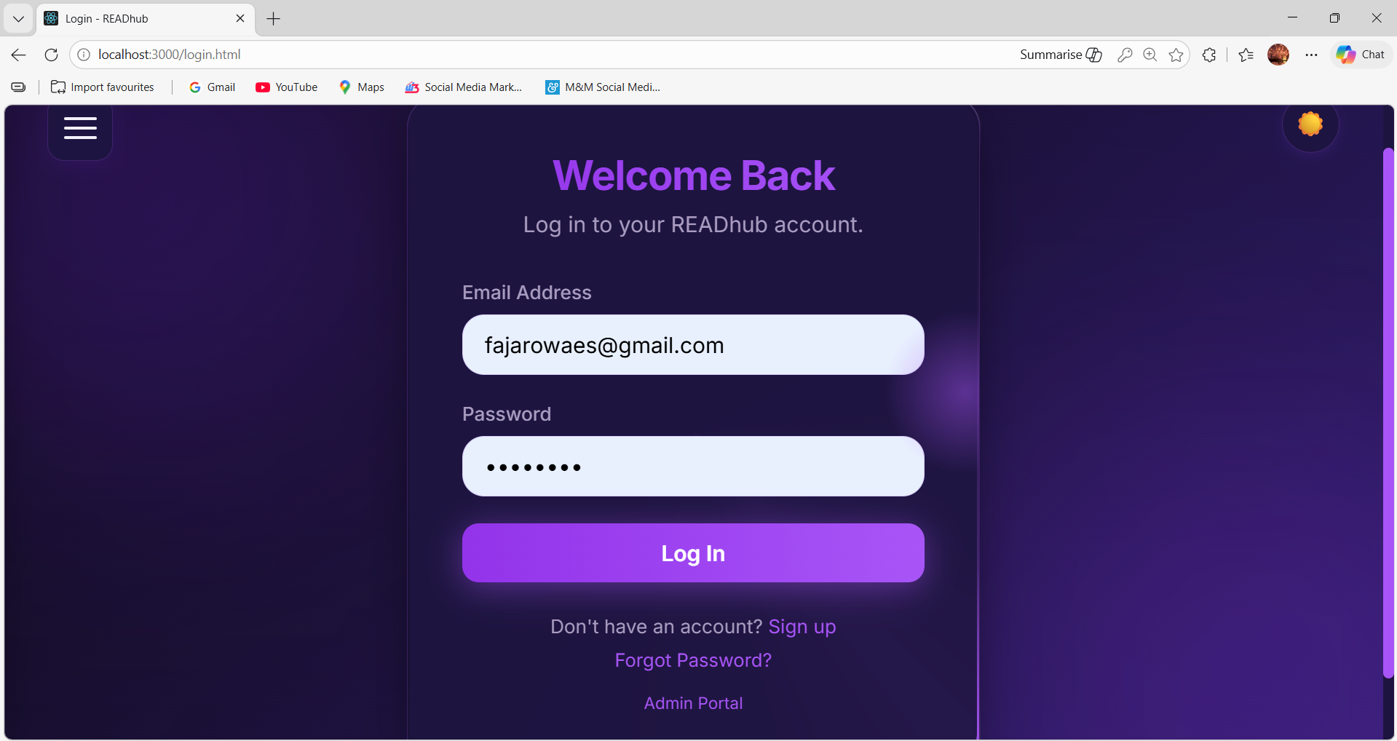

Admin login page:
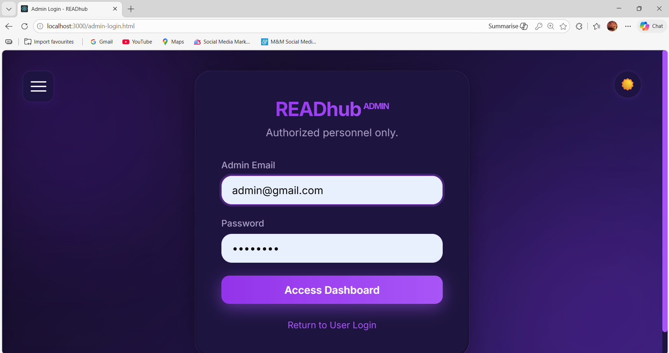

Admin Dashboard:
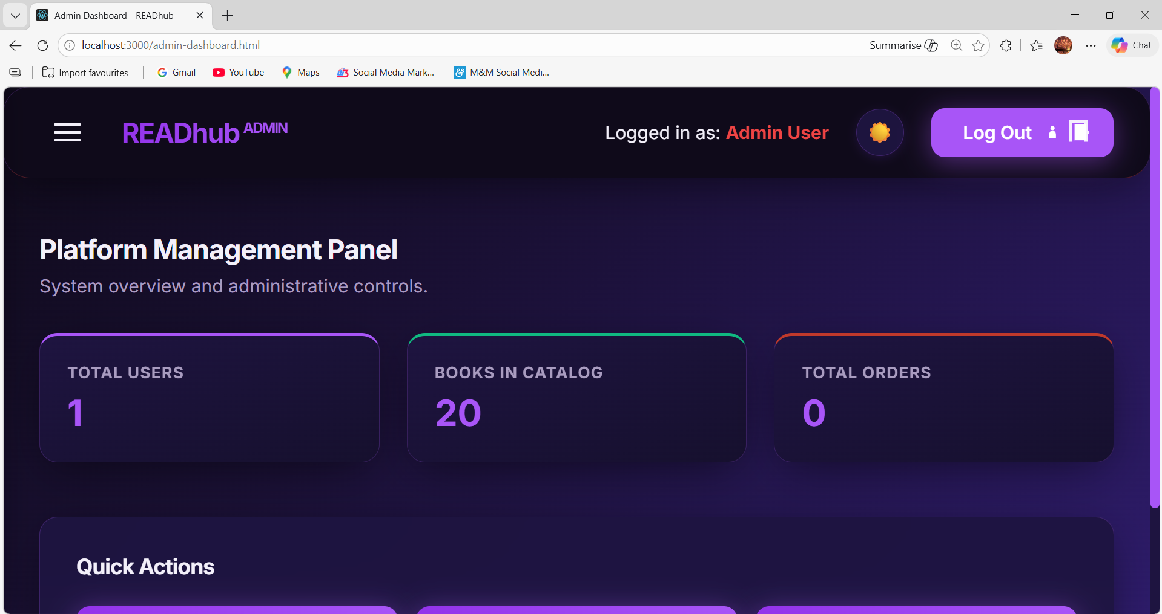

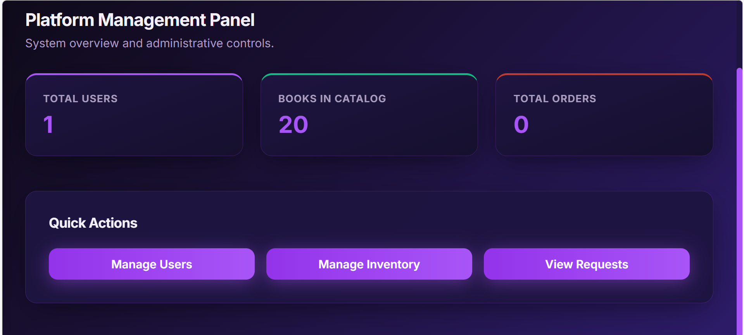

Manage Users:
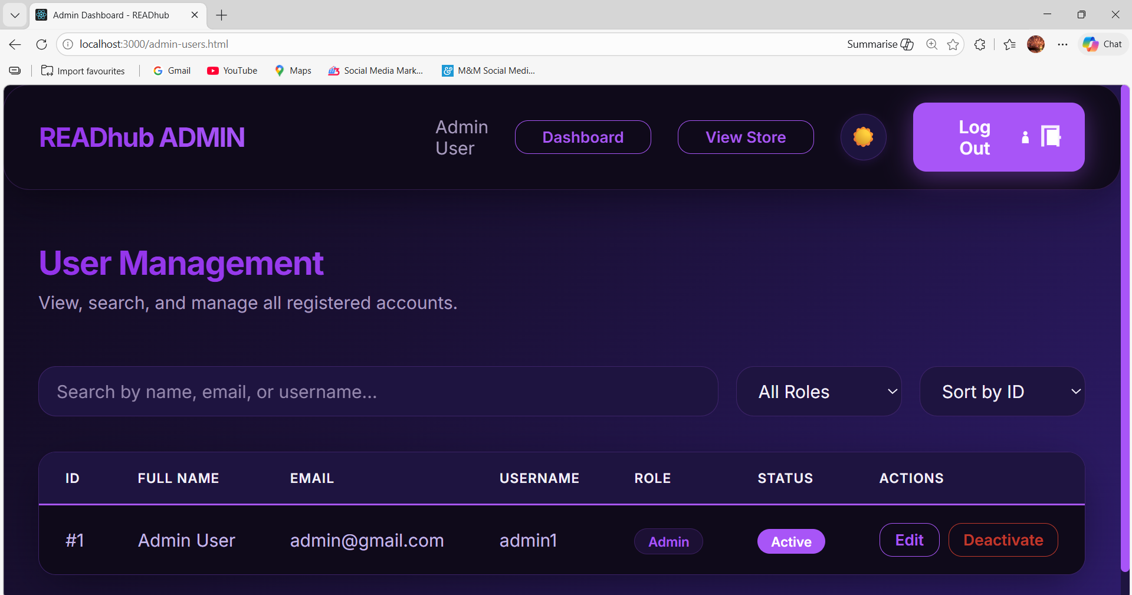

User Dashboard:
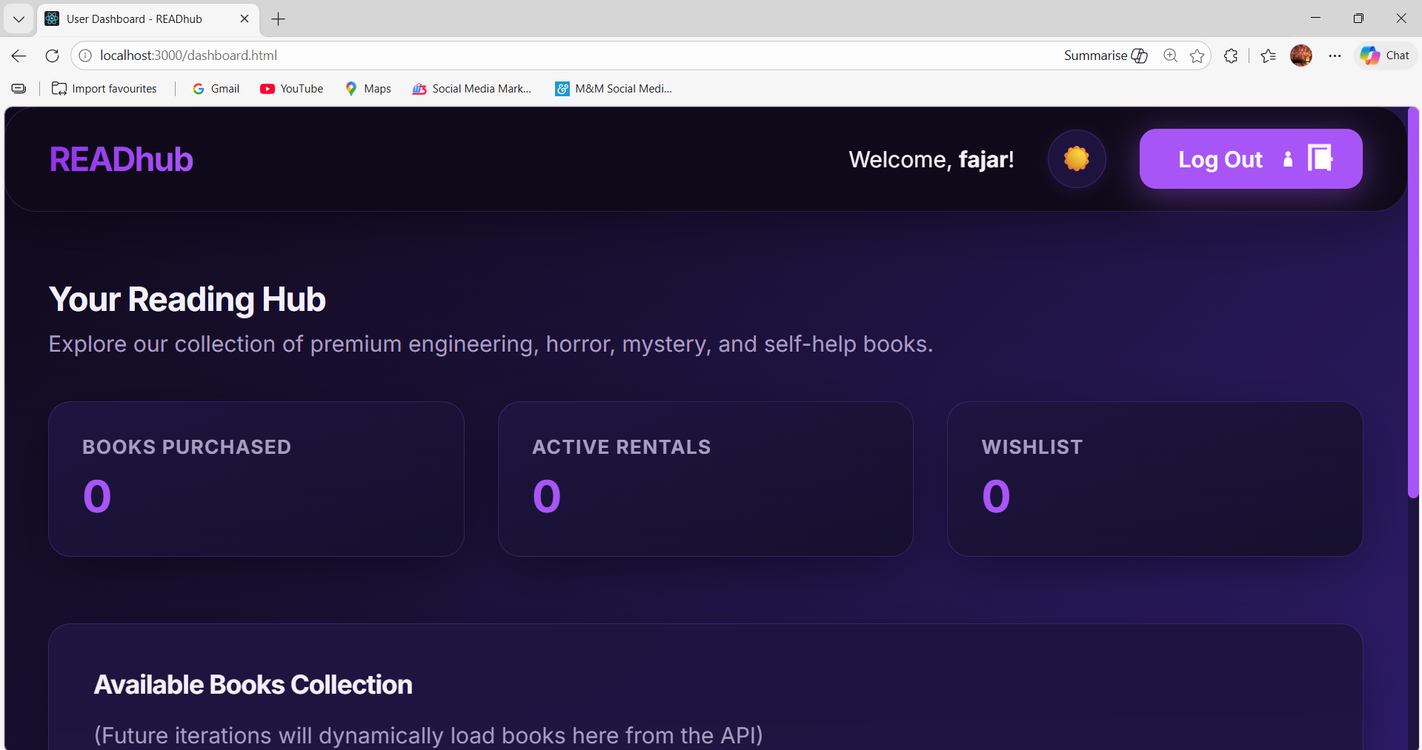

Work divison:
Kinza Saeed: Admin login, logout, Admin Dashboard, Manage Users
Fajar Owaes: User Authentication(login, logout), Trello Scrum Board management, partial Report D1
Syeda Urwa: Database, structured specifications, NFR, and burn-down chart

